How to use Purple Mash step by step
Step one  How to find tasks set by a teacher | 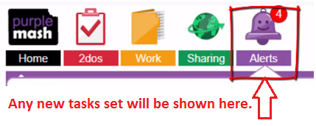
Step two  How to return to tasks | 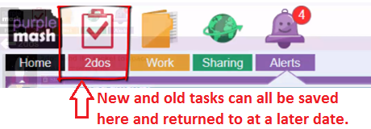
Step three  How to begin a task | 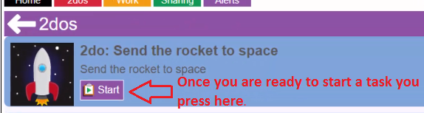
Step four  How to save work and return to it later | 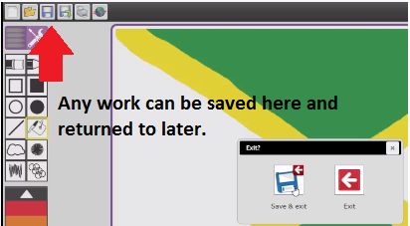
Step five  How to submit a task so your teacher can see it | 