Computing

The children will be cracking codes; looking at how information was kept secret, early communication and passwords.

Science

Science this half term will focus on Forces; working scientifically to explore gravity, air resistance and how forces work around us.

RE

In RE this term the children are going to explore Judaism: important artefacts, Jewish rules and food.

Homework

Children should try to read 3 times a week and have an adult sign their planner. They should practise Timetables Rock stars to be as speedy as they can!

PE

The children will participate in two PE lessons a week with myself and Elite coaches.

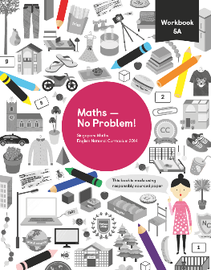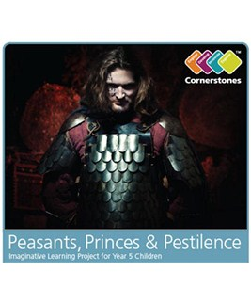

Year 5

Autumn 2

Creative Curriculum

This half term we will be looking at the topic ‘Peasants, Princes and Pestilence’.

‘Flee your fields, closes your doors and pull up the drawbridge: the dreaded and deathly ‘Great Pestilence’ is here! Mount your steed and gallop through the dark and deadly world of 14th century Britain!’

Maths

This half term we are looking at multiplication and division. We will explore how to answer word problems effectively before moving onto graphs in Statistics.

English

Great Expectations

By Charles Dickens

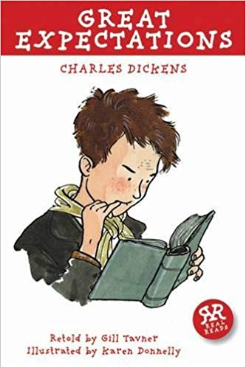

We will be continuing our new English curriculum using a book to hook the children into writing. We will be looking at the classic story Great Expectations. Alongside this we will we will focus separately on comprehension skills, spelling and the grammar for Year 5 and 6 within separate SPaG lessons,