Year 6 Autumn 1
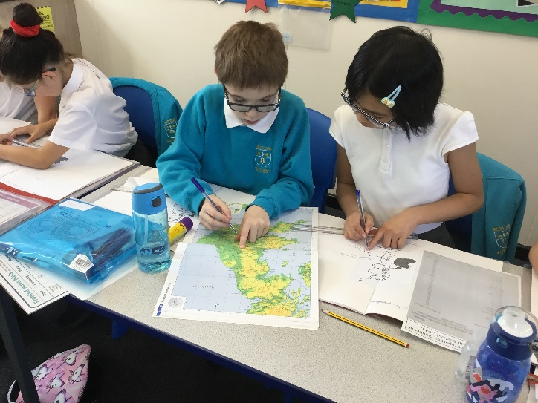
To begin our first half term, we explored the history of World War II. We used primary sources, such as government bombing records to explore where in England the Germans were most likely to target. We created propaganda posters and researched the allies and axis countries and their leaders at the time. In art, we took inspiration from Hans Liska (a German soldier) to create our own sketches to depict war scenes.
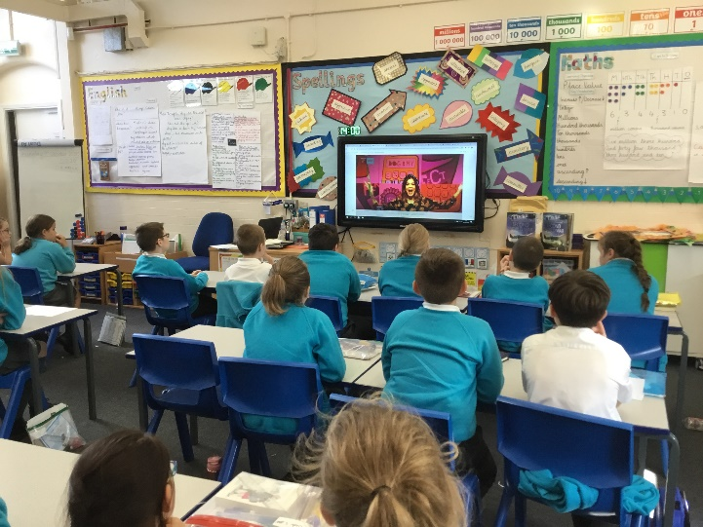

We had a live visit from the BBC
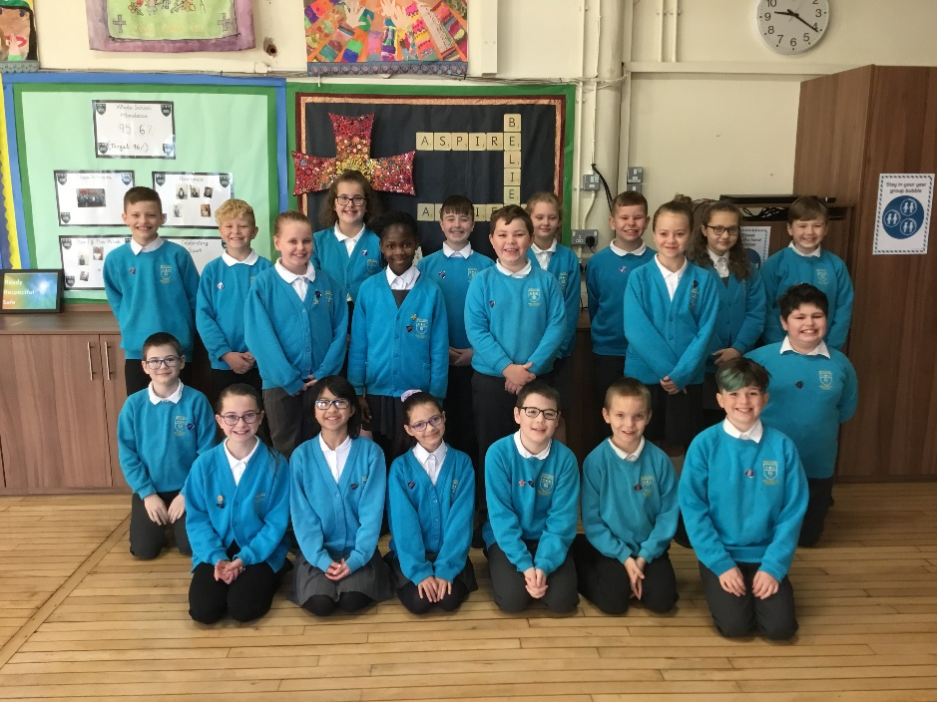
who took our feedback on board about future programmes. They also gave us a never seen before episode of ‘The Dumping Ground’ to see before anyone else!
Our prefects were chosen and have been doing an amazing job. Look at those smiles!
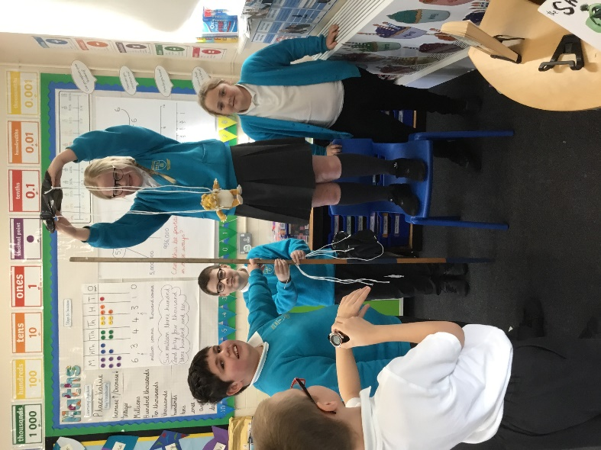

Science has been jam packed with investigations on forces such as air resistance, water resistance, friction and gravity.

Science

