Year 4 Highlights for Autumn One
In Art, we were inspired by Roman mosaics. We analysed mosaics from Roman times explaining what we liked and disliked about them and then we designed our own Roman mosaics. We practised our skills in collage by firstly creating our design using squares of coloured paper and finally used ceramic tiles and grout to create our own mosaics.
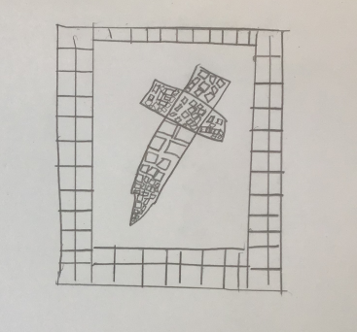
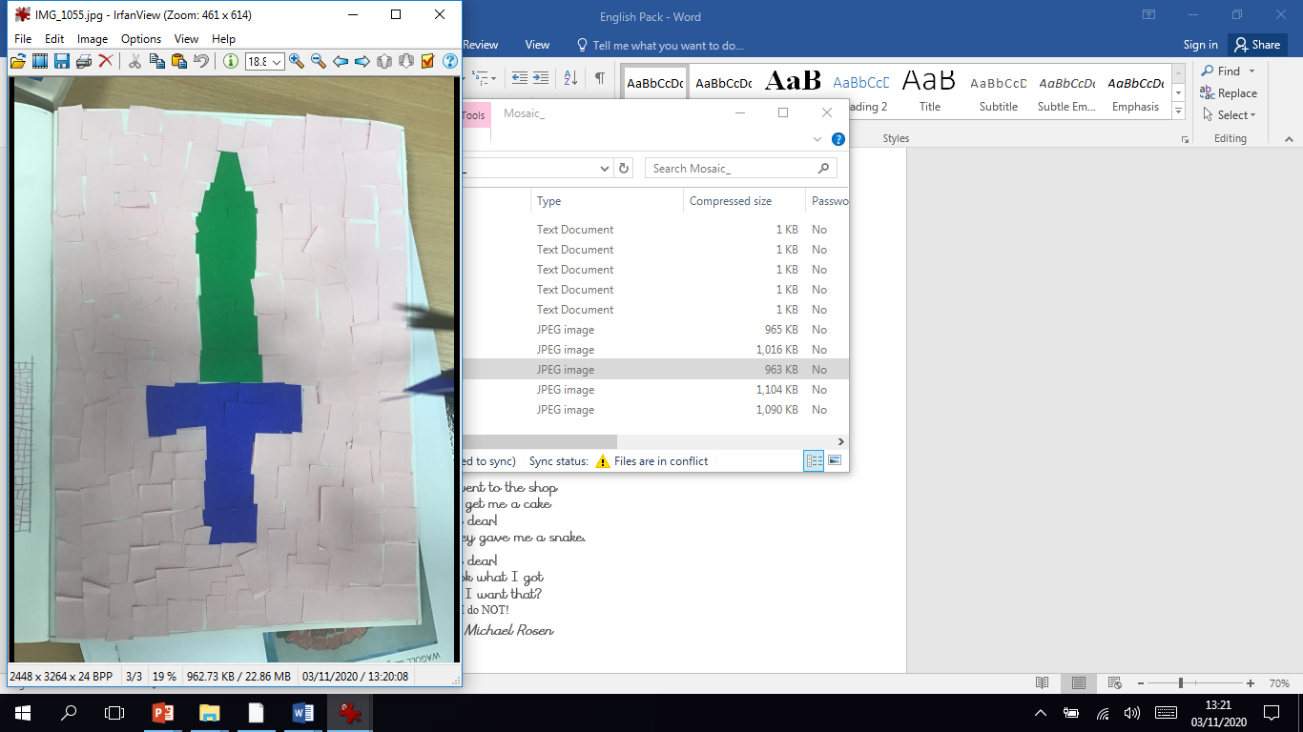
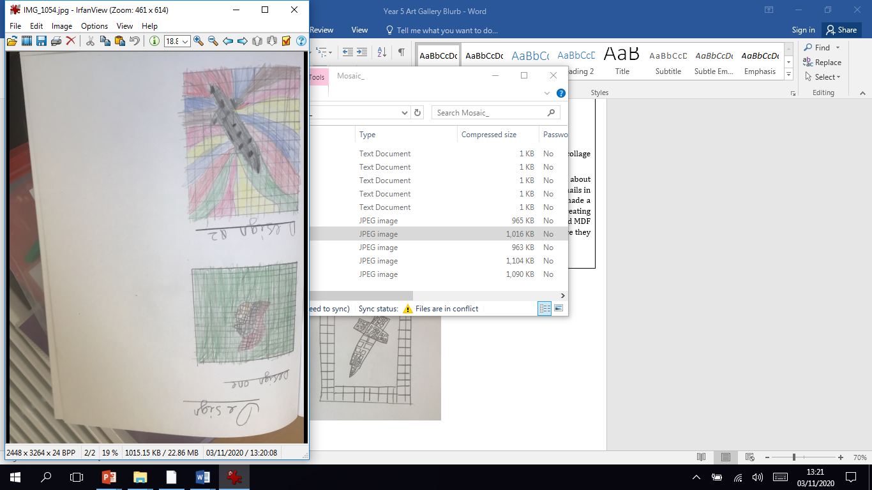

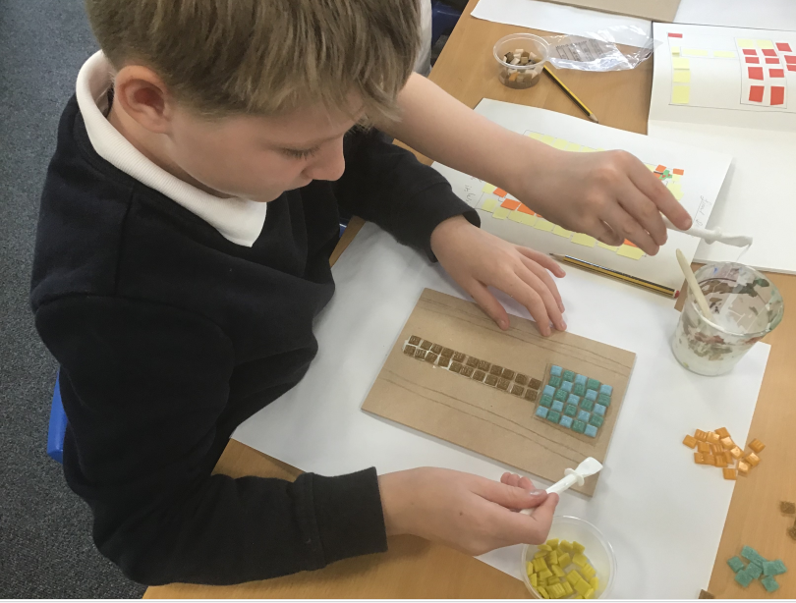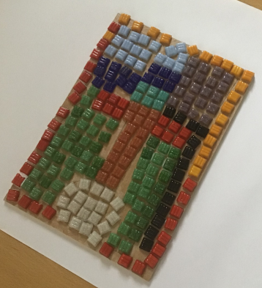

We studied the journey the Roman Army took across Europe to invade Britain. We learned that the Roman Army consisted of people from many different countries that had joined the army as they successfuully invaded all different countries throughout Europe.
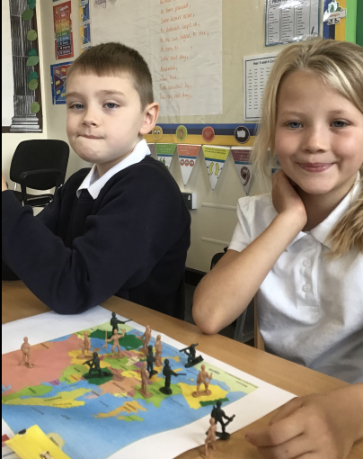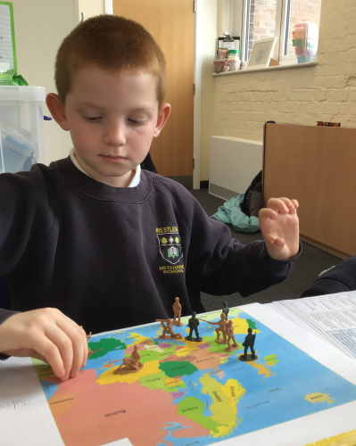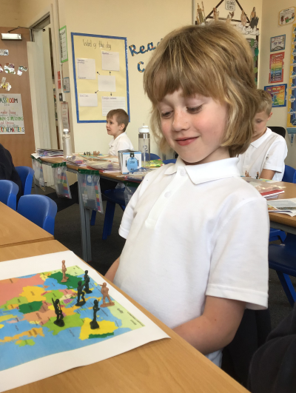

In Maths, the children have worked in teams to answer a range of tricky questions in a variety of ways.
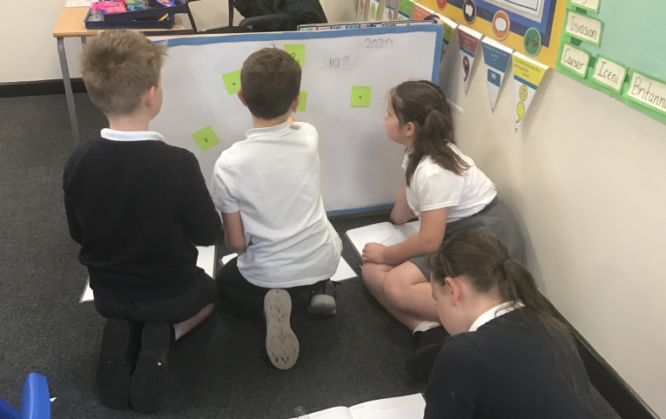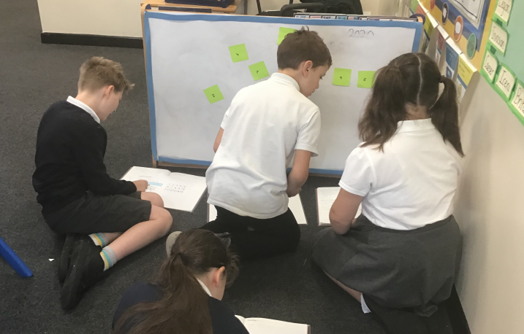
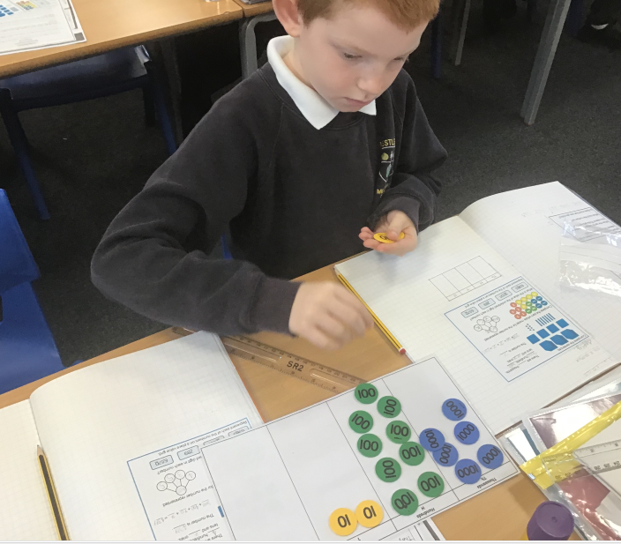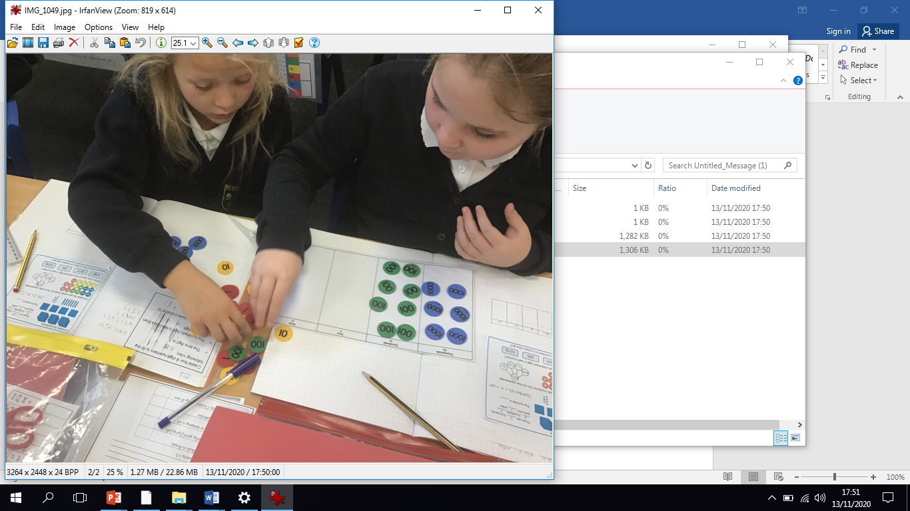

As part of our Harvest Worship we created a poem to share the things we had learned about the Methodist charity ‘All We Can’. We also created posters because we thought it was such an amazing thing to provide a bike and change a person’s life so dramatically.
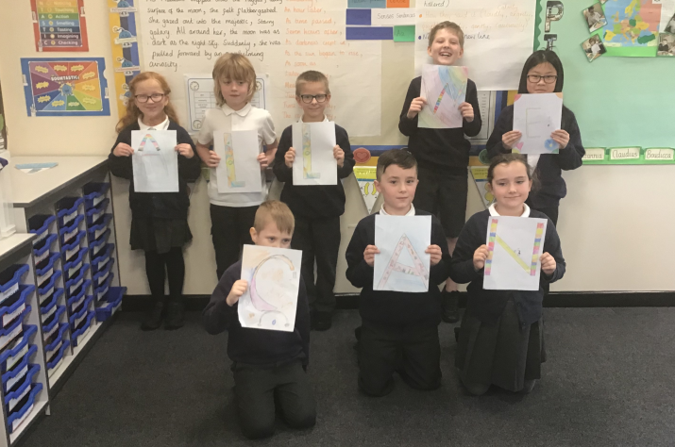
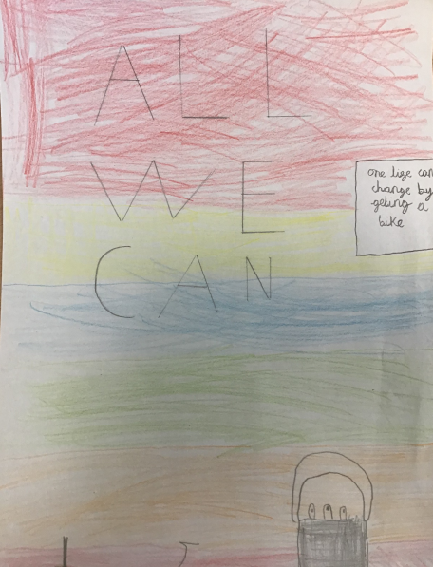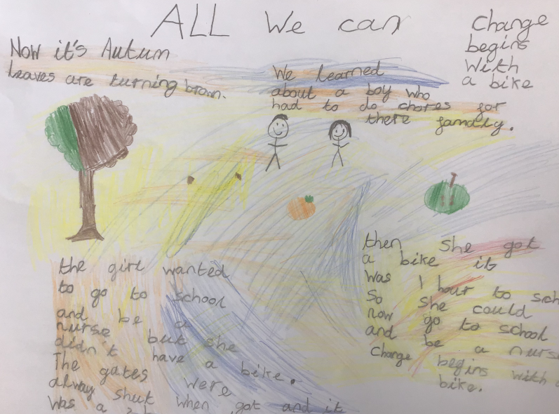
We have really enjoyed our African drumming lessons do far. Mr Parr tells us that we have got fantastic rhythm!
