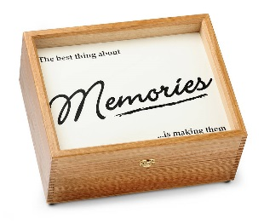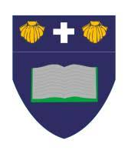

**Creative Curriculum**

This half term our Creative Curriculum topic is Memory Box!

As Historians, we will be finding out about the past after our discovery of a time capsule! We will be asking questions about how our local area has changed since the 1900s, how toys have changed and how our school has changed. We will be using a range of sources such as pictures, real artefacts and first-hand experiences from older adults.

As Geographers, we will focusing on our school environment, We will be making our own maps, using a key, to show people what the school layout is like now.

As Designers, we will be designing, making and evaluating our own moving Christmas cards!

Year 1

Curriculum Map Autumn Term 2

English

As readers, we continue to use Read Write Inc to teach phonics. Your child will be learning all the phonemes and graphemes, through a differentiated approach. This will ensure that they are confident to segment and blend the learned sounds when reading real and alien words. Also, your child will engage in daily reading through the scheme. They will read a text that is closely suited to their current phonetic knowledge. It will encourage them to segment and blend sounds they are familiar with, as well as ‘tricky’ words.

Your child will be sent home a Book Bag Book, which has been selected to reinforce their phonetical knowledge and reading skills outside of school. As a school, we recognise that importance of reading and suggest that 5 minutes is spent every night to enjoy reading together. Your child will also receive a weekly library book.

As writers, we will be using a picture book as a stimulus for our writing, through a Book as a Hook curriculum. This half term our book is ‘The Polar Express’. We will be practising our sentences out loud before we write them down. We will also be using a sound mat to ensure that we are trying our best to spell words accurately.

As Scientists, we will be learning about the different parts of the human body, our organs and our senses. We will be labelling our own human body. We will be putting our senses to the test in a range of scientific investigations to explore how they really work.

In Computing, we will be navigating our way around Purple Mash. We will be exploring how to login, our avatar and how to play some of the fun games. We will also be learning how to be safe online.

In PE, we will be working with Elite Sport on a Tuesday afternoon. Please ensure your child has kit every Tuesday.

As Musicians, we will be working with Mr Glover to develop our musical talents! We will be singing, finding the beat and enjoying lots of music.

Religious Education

Our RE focus question is ‘Why do Christians celebrate Christmas?’

Spiritual: Explore the idea of giving and receiving gifts. Pupils reflect on their own experience of gifts and gift giving. Is it better to give or receive a gift?

Moral: Explore with pupils which gifts are the most valuable and why.

Social: Explore how Christmas is celebrated by Christians in the church.

Cultural: Explore how Christmas is celebrated in the UK.

**Maths**

As mathematicians, we will be discovering different strategies that will help us to confidently add and subtract numbers up to 10. We will be learning in many practical ways and applying these skills in our written work.