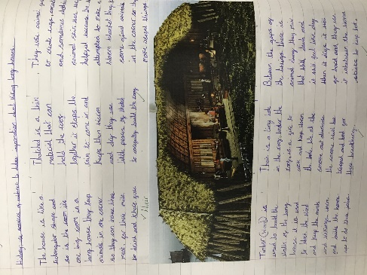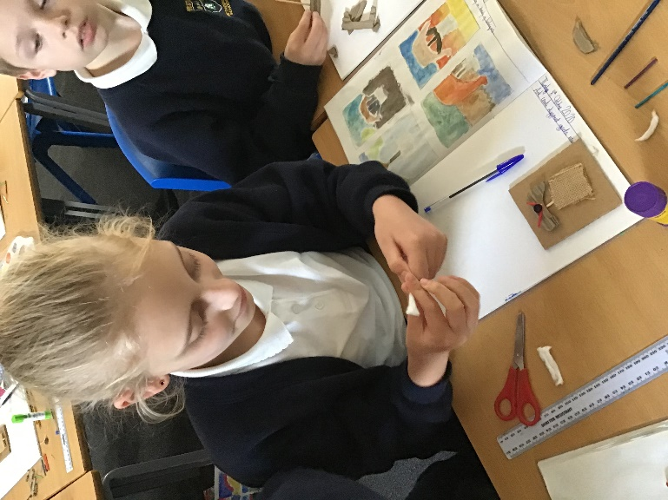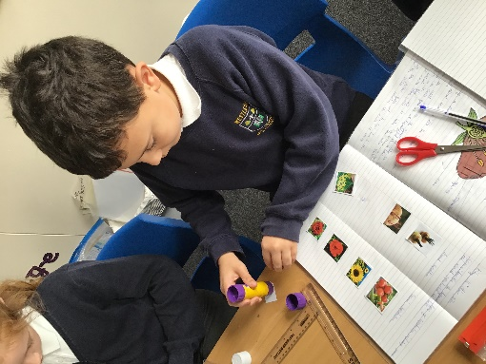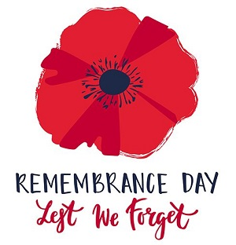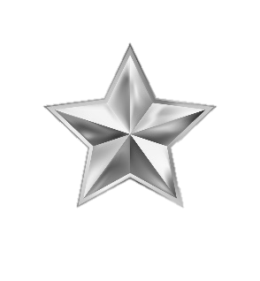

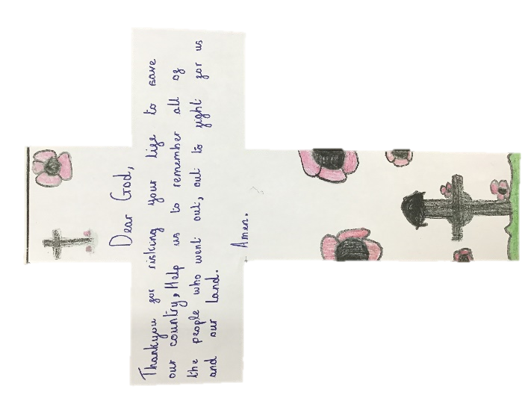

Super scientists

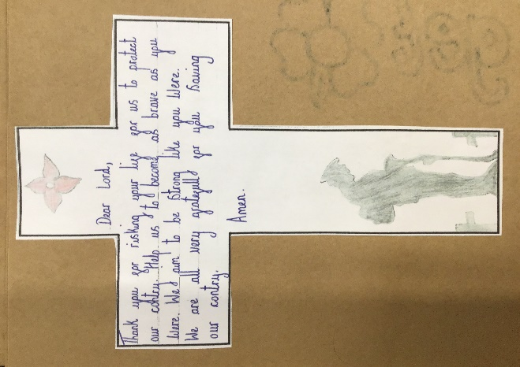

Don’t forget to look on class dojo and TWITTER for more images of their work

Next term, we will learn about the Anglo-Saxons and in Design and Technology. e will create patterns like their tapestries using plastic sewing needles and weaving cards.

Year 5 experimented with mono-printing and collograph. They used different materials to create a 3D stamp to print with.

In History, we learnt about the Vikings. We discovered where they came from, how they travelled and where they settled.

History

During the Autumn term 1, Year 5 learnt about the artist Henry Matisse. They learnt about how he uses colour and repeating patterns.

As scientists this term, Y5 learnt about different lifecycles of animals, including amphibians and mammals. They created fantastic 3D lifecycles of a butterfly and learnt about how they go through metamorphosis.

Year 5 created some amazing designs for our display in school for Remembrance Day. They created some fantastic prayers and made some fantastic reflections about the stories that we heard.

Remembrance Day

AMAZING ARTISTS

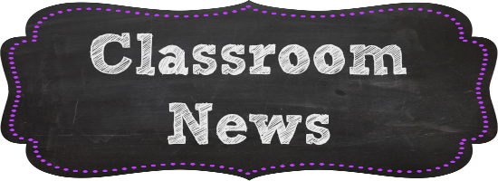

Y5

We also experimented with the technique wax resist using wax crayons and water colours.

Autumn term