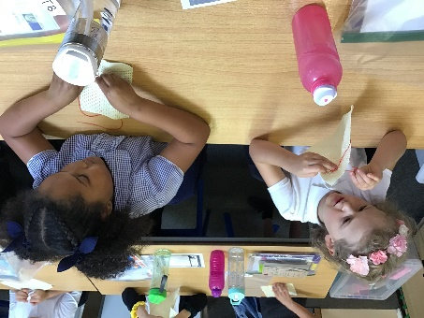
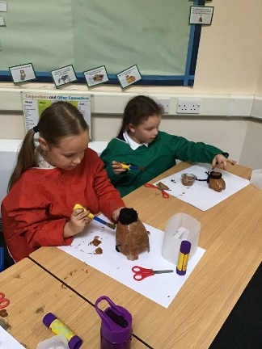
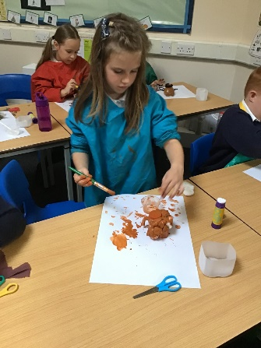
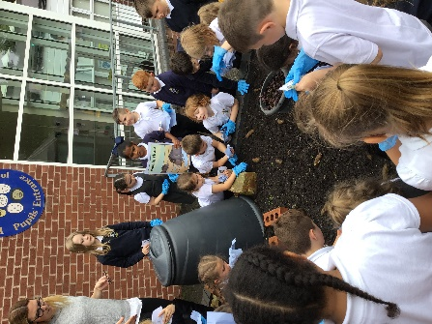
Year 3
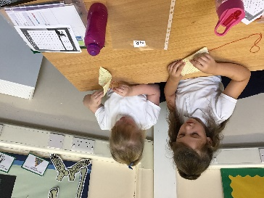
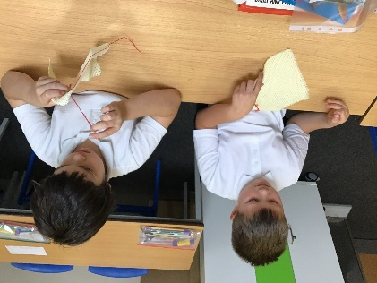
Year 3 have had so much fun in our first term. We have learnt how to experiment with different types of stitches to produce our own Stone Age art embroidery patterns.
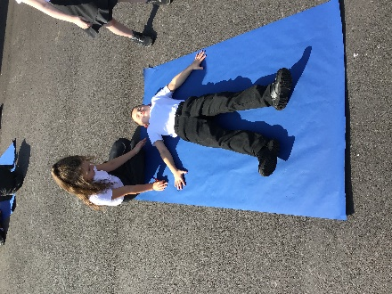
In science, we have learnt about the functions of skeletons and named some of the main bones. We have also learnt what our bodies need to survive and stay healthy.
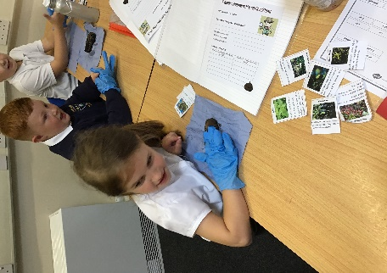
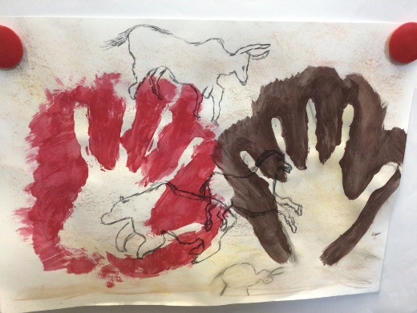
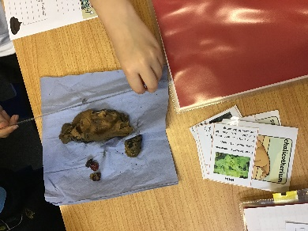
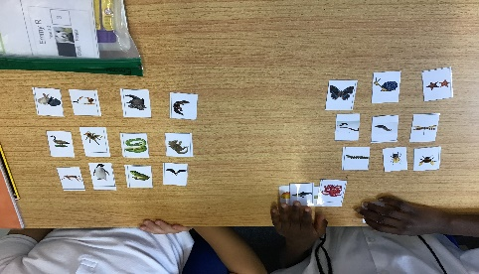
Our topic lessons have been really exciting, learning about the Stone Age! We have studied the very first houses and what they were made of. Also, we have produced some amazing pieces of art including milk bottle mammoths and cave art collages. Our favourite discovery was the artefacts and poo found in the playground, which we then dissected to investigate what the hominins back then ate! Yuck!

