

RE

‘Why, where and how do Hindus worship?’ In RE we will enquire and explore the concept of worship in Hinduism.

Computing

In computing, the children will be predicting and running code to investigate, modify and create their own games.

Science Science this half term will focus on ‘Living things and their Habitats.’ We will look into how and why animals are classified into different groups and explore the work of scientists who have worked in this area.

Art In Art, we will be taking inspiration from Henry Moore to sketch and create sculptures inspired by WWII.

Year 6

Autumn 1

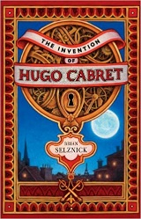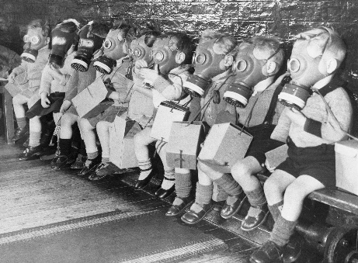

Creative Curriculum

World War II

In Creative curriculum we will be: investigating and interpreting the past; understanding chronology and where World War II fits into history. We will delve into World War II exploring how life was for people in those times.

English The Invention of Hugo Cabret Brian Selznick

We will continue our English curriculum with a ‘Book as a Hook.’

Our first book this year is Hugo Cabret. As readers, we will use inference to gain information from the story, We will continue to work on our comprehension skills in discrete SPaG lessons. As writers, we will use this to write diary entries, monologues and newspaper reports building on our understanding

of the story.

PE

The children will participate in two PE lessons a week with myself and Wigan Athletic. This half term the focus is gymnastics.

Maths

This half term we will be looking at the place value of digits up to millions, negative numbers and the four operations: addition, subtraction, division and multiplication. We will continue to use fluency, reasoning and problem solving to answer questions on this in preparation for SATs and will be continuing to work on our arithmetic skills.