**As Scientists we will;**

* identify and describe the functions of different parts of flowering plants: roots, stem/trunk, leaves and flowers
* explore the requirements of plants for life and growth (air, light, water, nutrients from soil, and room to grow) and how they vary from plant to plant
* investigate the way in which water is transported within plants
* explore the part that flowers play in the life cycle of flowering plants, including pollination, seed formation and seed dispersal

**As Historians we will;**

* Learn about late Neolithic hunter-gatherers and early farmers, for example, Skara Brae
* Explore Bronze Age religion, technology and travel, for example, Stonehenge
* Discover all about Iron Age hill forts: tribal kingdoms, farming, art and culture

**In R.E we will be;**

Looking at the question *‘What makes some books sacred?’* We will explore books that are special to us and how sacred texts are shown respect by believers

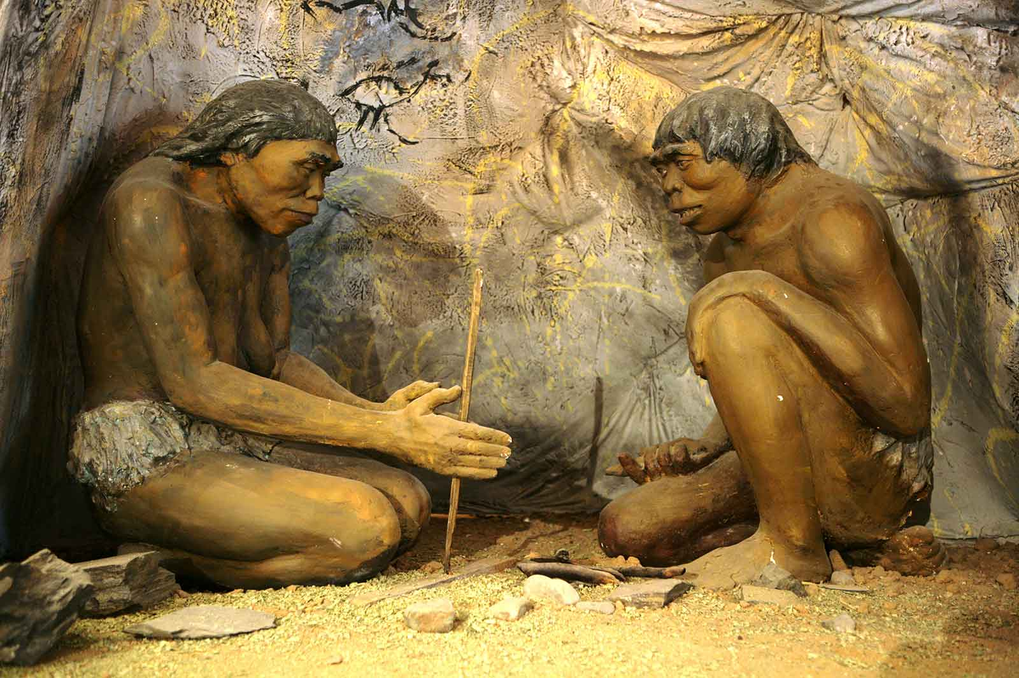

**As Mathematicians we will;**

* **Represent numbers to 100**
* **Tens and ones using addition**
* **100s, 10s and 1s**
* **Compare objects and numbers to 1000**

**Autumn One**

**Year 3**

**As Musicians we will be;**

Learning how to use our voices and bodies as instruments by studying body percussion

**As writers and readers we will;**

Using the book *‘Man on the Moon’* by Simon Barton as a hook, we will write predictions, diary entries, character descriptions, setting descriptions and finally a short narrative.

Our grammar focus will be to study word classes

Our Class Novel will be *‘The Wild Way Home’* by Sophie Kirtley

**In Computing we will be;**

Developing our coding skills using Purple Mash

**As Artists we will;**

Study the parable of Jacob and Esau and explore how forgiveness can lead to inner peace. Then use granite to draw representations of the story.