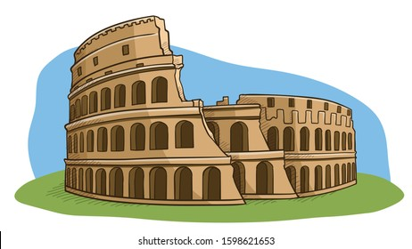

Maths:

We will be focusing on place value in numbers up to 10,000. We will compare and order 4-digit numbers. We will also be looking at addition and subtraction, improving our mental strategies and working with remainders.

English:

Our book as a hook is ‘Escape from Pompeii’ by Christina Balit. We will be developing our writing skills by creating pieces of writing for a variety of genres including adventure narratives, explanation texts and newspaper reports.

As Geographers we will:

Use digital mapping programmes of Rome to locate significant geographical features. We will be comparing and contrasting the UK to Italy, looking at size, climate and landscape.

As Scientists we will:

Investigate our amazing digestive system and learn about how it all works! We will also be learning about the different types of teeth we have and why it is important to keep them healthy.

As Artists and Designers we will:

Refine our sketching skills by creating drawings of Mount Vesuvius. We will use shading and tone to create texture in drawing the effect of light. We will also practise using the technique of cross-hatching.

Year 4 – Autumn 1

Curriculum Map

As Historians we will:

Focus our learning on the Roman Empire and its impact on Britain. We will be using timelines, sources and artefacts to enquire into the question ‘What did the Romans do for us?’ We will be learning about the lives of Gladiators, warriors and Queen Boudicca, the ruler of the Iceni tribe. We will also be looking at different structures the Romans built including Hadrian’s Wall.

R.E.:

We will be investigating the question ‘Can religious teachings help us decide the best way to live?’ We will explore the importance of rules and reflect on what we can learn from moral stories.