


Safe Sleep Protocol

Purpose

Sleep is a normal part of provision for some children in our provision. We recognise that young children may require a daytime sleep as part of their individual routine, development and wellbeing.

This protocol sets out the arrangements that will be followed to ensure that children who sleep during the school day are cared for safely and in accordance with the EYFS Statutory Framework, effective from 1 September 2026.

Our approach recognises that children have different sleep needs. Staff will work in partnership with parents/carers to understand each child's usual sleep routine and respond appropriately to their individual needs.

Where a child has an identified, regular or additional need relating to sleep, this will be discussed with parents/carers and, where appropriate, reflected in the child's individual provision, risk assessment or support plan.

Designated Sleep Space

The school has a designated sleep space for children in the two-year-old provision.
The sleep space is located at: [INSERT LOCATION]

On occasion, children in our pre-school or Reception may fall asleep, although this is not typical. We do have safe designated sleep spaces for this eventuality. The designated area for pre-school is [INSERT LOCATION] and Reception is [INSERT LOCATION].

The designated sleep spaces provide a calm, quiet and comfortable environment away from the main flow of activity while ensuring that children remain appropriately supervised.

The sleep space must be:
- within the EYFS provision and easily accessible to staff;
- quiet and calm, with lighting appropriate for sleep;
- free from hazards and objects that could obstruct a child's breathing;
- maintained at a comfortable temperature;
- appropriately ventilated;
- free from unnecessary soft furnishings, loose items and other potential hazards;
- arranged so that children remain within the sight and/or hearing of staff in accordance with the setting's supervision arrangements;
- checked regularly to ensure that it remains clean, safe and suitable for use.

Children should not be left sleeping in areas that have not been designated or assessed as suitable for sleep.

Equipment

The designated sleep space will be equipped with suitable sleep surfaces appropriate for children over 12 months.

A suitable firm, flat and clean sleep mat will be provided for each child as appropriate.

The sleep surface must:
- be firm and flat;
- be clean and in good condition;
- be appropriate for the child's age and stage of development;
- be free from unnecessary items;
- be positioned safely within the designated sleep space.

The following must not be used as a sleep surface:
- a yoga mat;
- a thin exercise mat;
- a beanbag;
- a cushioned play mat;
- a soft foam cushion;
- any other surface that is soft, excessively padded or not designed for sleep.

Any equipment used for sleep will be checked regularly and removed from use if it becomes damaged, unsafe or unsuitable.

Bedding and Clothing

Children should sleep in comfortable clothing appropriate for the temperature of the room.

Where a child requires a covering, clean, lightweight bedding appropriate to the child and room temperature may be provided.

Bedding will:
- be clean and in good condition;
- be washed regularly and whenever soiled;
- be stored clean and dry;
- not cover the child's head or face;
- not be excessive or likely to cause overheating;
- not include unnecessary soft items within the child's sleep space.

Pillows, duvets, cushions and other unnecessary soft items will not be placed within the child's sleep space.

Staff will consider the child's clothing and bedding together to ensure that the child does not become too hot.

Supervision

Children who are sleeping will remain appropriately supervised by EYFS staff.
Staff will:
- check children regularly while they are sleeping;
- ensure that children remain on the designated sleep surface;
- ensure that the child's face and head remain uncovered;
- check that the child is not too hot or cold;
- remain alert to any changes in the child's condition;
- respond promptly if a child becomes unsettled, distressed or appears unwell;
- maintain appropriate supervision of the wider provision while children are sleeping.

The frequency and nature of sleep checks will be appropriate to the child's age, individual needs and the setting's risk assessment.
Staff must be able to respond immediately if a child requires assistance.

Individual Sleep Routines

Parents/carers will be asked to share information about their child's usual sleep routine when the child starts at the setting.
This may include:
- usual sleep times;
- approximate duration of sleep;
- signs that the child is becoming tired;
- usual settling routine;
- comfort items or familiar routines, where appropriate;
- any relevant medical, developmental or sensory information;
- any changes to the child's normal sleep pattern.
The setting will seek to work in partnership with parents/carers while recognising that children's sleep patterns may change as they develop.

Children will not be expected to sleep simply because it is a designated sleep time. Staff will respond to individual cues of tiredness and the child's needs.

Where appropriate, children may be supported to settle for sleep using familiar and consistent routines.

Settling to Sleep

Staff will support children to settle calmly and safely.
Children will be placed on the designated sleep surface and unnecessary items will be removed from the immediate sleep area.

Staff will not use practices that could compromise a child's safety.

If a child becomes distressed or does not settle, staff will respond sensitively and consider whether the child needs comfort, reassurance, a change of activity or support from their key person.

Children will not be forced to sleep.

Unexpected Sleep

If a child falls asleep outside the designated sleep space or in pre-school / Reception:

- Staff will assess the situation and ensure that the child is safe.
- Where practicable and appropriate, the child will be moved to the designated sleep space.
- The child will be placed on the appropriate firm, flat sleep surface.
- Unnecessary soft items will be removed from the immediate sleep area.
- The child will remain appropriately supervised.
- Staff will check the child regularly while they are asleep.
- Parents/carers will be informed in accordance with the setting's normal communication arrangements.
- If the sleep is unusual, prolonged or appears to indicate that the child may be unwell or unusually tired, staff will speak directly with parents/carers.
- If there is a concern about the child's health or wellbeing, the school's normal first-aid, medical and safeguarding procedures will be followed.

Sleep Record

A sleep record will be maintained for children who sleep during the school day.

The record will include:
- Child's name;
- Date;
- Time the child fell asleep;
- Time the child woke;
- Where the child slept;
- Staff member supervising;
- Sleep checks made;
- Any concerns noted;
- Parent/carer informed;
- Any additional action taken, if required.
The sleep record will be stored securely and handled in accordance with the school's data protection and record-keeping arrangements.

See Appendix 1 – Sleep Record.

Communication with Parents/Carers

Parents/carers will be kept informed about their child's sleep during the school day.
The setting will establish with parents/carers how sleep information will normally be communicated.

Where a child:
- sleeps for a significantly longer or shorter period than usual;
- regularly falls asleep outside their usual routine;
- appears unusually tired;
- appears unwell;
- has a significant change in their normal sleep pattern; or
- requires additional support around sleep,
staff will speak directly with parents/carers and consider whether further information, advice or support is required.

Parents/carers will be encouraged to share any significant changes to their child's sleep routine or wellbeing with the setting.

Cleaning and Hygiene

The designated sleep space and sleep equipment will be maintained to a high standard of cleanliness.

Sleep surfaces will be:
- cleaned in accordance with the manufacturer's instructions;
- cleaned immediately if visibly soiled;
- checked regularly to ensure they remain clean, intact and suitable for use;
- stored appropriately when not in use, where applicable.

Any bedding used by a child will be removed after use and washed in accordance with the school's hygiene arrangements. Bedding will not be shared between children without being appropriately washed. The designated sleep space will also be cleaned regularly and whenever required to maintain a hygienic environment.

Temperature and Environment

Staff will ensure that the sleep environment is comfortable and suitable for sleeping.

Particular consideration will be given to preventing children from becoming overheated.

The sleep space will be kept away from direct sources of heat where possible, including radiators and other heated surfaces.

Staff will consider:
- room temperature;
- children's clothing;
- bedding;
- ventilation;
- individual needs; and
- any other environmental factors that may affect the child's comfort or safety.

Individual Needs

Where a child has an identified medical, developmental, sensory or other need that affects their sleep, the school will work with parents/carers and relevant professionals where appropriate to understand the child's needs and agree suitable arrangements.

Any individual sleep arrangements will be informed by relevant medical or professional advice and reflected in the child's individual risk assessment or support plan where required.

Where a child's needs change, sleep arrangements will be reviewed.

Concerns or Safeguarding Issues

Any concern about a child's health, welfare, sleeping arrangements or response to sleep will be discussed with the EYFS Lead and/or DSL, as appropriate.

Where a concern relates to:
- a child's health or wellbeing, appropriate first-aid or medical procedures will be followed;
- an individual child's needs, this will be discussed with parents/carers and relevant professionals where appropriate;
- safeguarding, the school's Child Protection and Safeguarding Policy and local safeguarding procedures will be followed;
- the suitability or safety of the environment or equipment, the equipment or area will be removed from use until the concern has been addressed.

Any serious safeguarding concern will be reported immediately to the DSL.

Staff Responsibilities

All EYFS staff will:
- be familiar with this Safe Sleep Protocol;
- understand the school's arrangements for planned and unexpected sleep;
- understand the individual sleep needs of the children they work with;
- ensure children are appropriately supervised while sleeping;
- use only designated and suitable sleep surfaces;
- remove unnecessary soft items from the sleep space;
- monitor children's comfort and wellbeing;
- complete sleep records where required;
- communicate appropriately with parents/carers;
- report concerns promptly; and
- familiarise themselves with current DfE and NHS safer-sleep advice.

Review

This protocol will be reviewed regularly and whenever there are significant changes to statutory guidance, the EYFS provision, equipment or the needs of children attending the setting.

Appendix One – Sleep Record
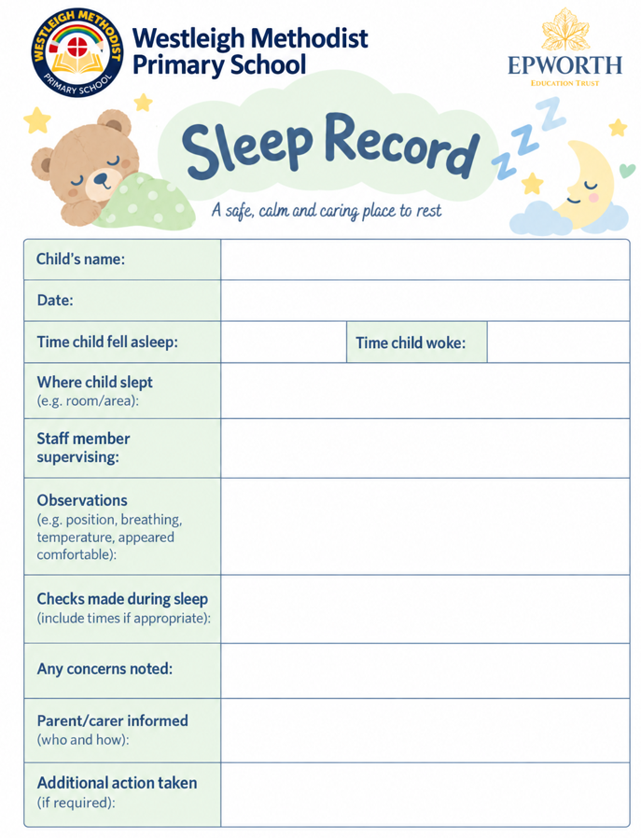
Appendix Two – Sleep Protocol for Display


