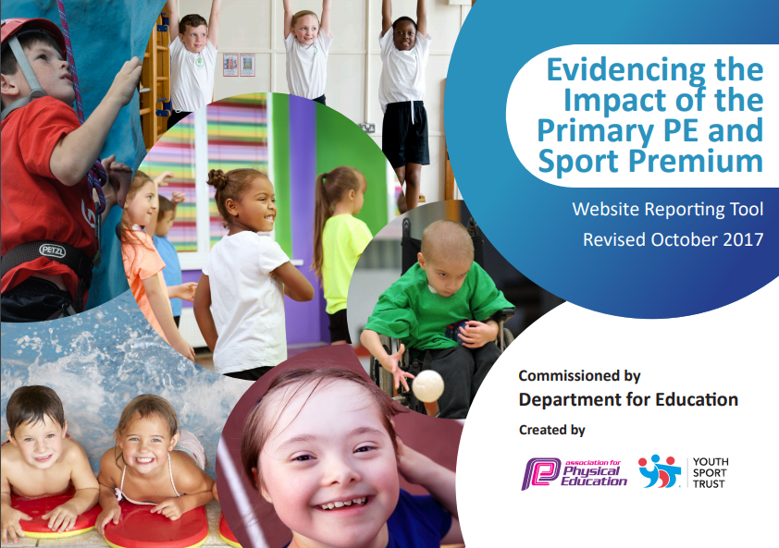

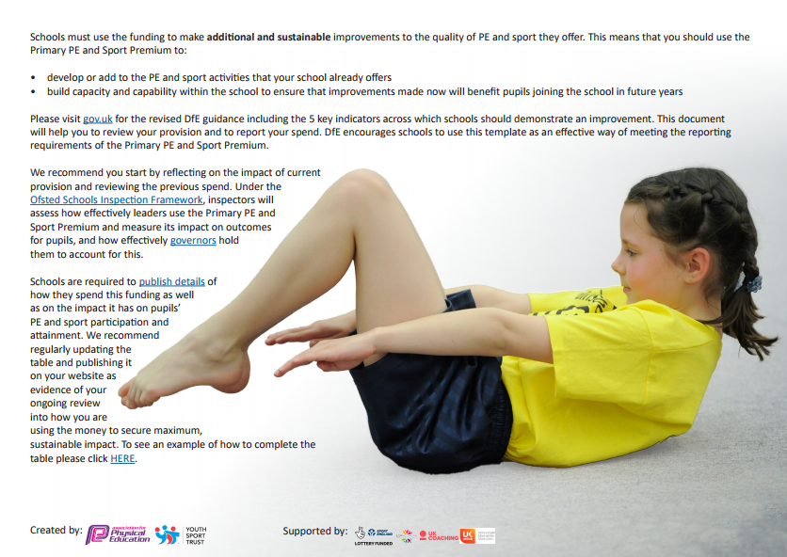
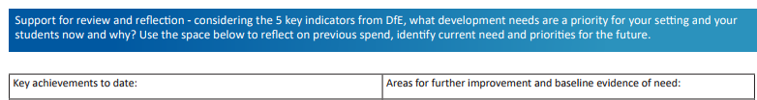

- Incorporating Maths and Literacy within PE lessons.
- Expanding staff’s CPD with the delivery of PE lessons.
- Pupils engaging in competitive sport and staff preparing those selected children for the event.
- Achieving Gold in the Sainsbury’s School Games for the academic year of 2016 – 2017.
- Competing in inter-competitions across both key stages.
- Organising intra-competitions termly and gaining high participation from children within school.
- Every pupil within Westleigh Methodist is accessing the government requirement of 2 hours per week.
- Competing in the National Daily Mile competition and receiving a signed certificate from Andy Burham.
- KS1 pupils participating in gymnastic workshop and meeting Gold gymnast, Beth Tweddle.
- Athletic star, Jenny Meadows, ran an afterschool club and identified a pupil as being gifted and talented in running.
- Fun raised for Sports Relief.
- Additional swimming interventions for children in KS2 who have no passed the NCA requirements.

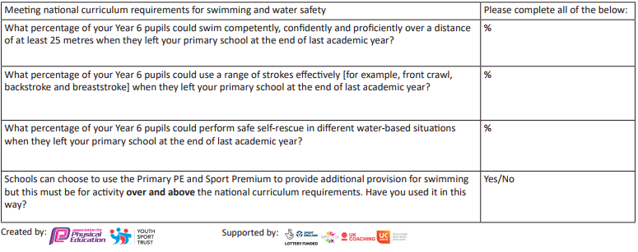
75%

75%
75%

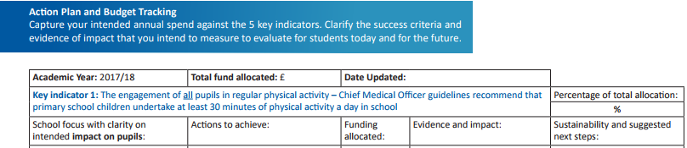
£22161 11.07.18
12%

- Pupils receive the government recommended two hours of PE a week to promote engagement in sport and encourage a healthy lifestyle.
- Daily Mile to be done before each PE lesson or as a brain break in lessons.
- Lunchtime games are ran by Elite 4x a week to encourage reluctant children to take part in physical activities and to promote social development.
- Developing skill based learning within different contexts and sports by following the Language Centre Publications Limited (LCP) PE lesson plans.
- Walk to school program introduced for all key stages to promote healthier options for children, adults and the wider community.

- Planning scrutiny to ensure consistency through school and subjects.
- Maintaining a strong partnership with Westleigh High School to ensure all key stages have the opportunity to timetable in 2 hours of PE a week.

- Pupils are becoming more active out of school and joining clubs. Children who have previously participated in inter-competitions have now gone onto joining athletics clubs outside of school.
- Teacher’s plan specifically for struggling and advanced learners to ensure the curriculum can be accessed by every pupil. In addition, there is opportunity for challenge to promote further skill development.
- Strong links with Westleigh High School remain and pupil voice from upper KS2 children have showed they feel privileged to be chosen to go to the high school. They also become more familiar with the layout of the High School which will help for a smooth transition.
Elite 4x clubs (lunchtime) £2753
- Monitor planning from teacher to ensure 2 hours of PE is being taught weekly.
- Continue the strong relationship with Westleigh High School by arranging for Y5 and Y6 to deliver their PE lessons (Autumn term).
- Long term plan influenced by pupil voice stating what lunchtime activities the children will take part in daily.
- Ensure all staff are monitoring the children’s travel to school daily in order to contribute to additional exercise for the children.
- Pupil voice (SL and AL learners on their experience of PE and on how using the high school has promoted a fluent transition).

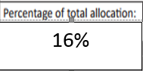
12%

- To monitor planning to ensure that there are opportunities for mental Maths and English skill rehearsal through Physical Education and School Sport. Providing a range of real life context to apply these skills.
- Sports notice board to highlight the profile of PE in school - to inform about upcoming competitions and recent achievements of the children.
- Provide additional swimming provision targeted to pupils not able to meet the swimming requirements of the national curriculum.
- Continue to promote PE via the school’s weekly newsletter, Classdojo and the school’s Facebook page to maintain strong parent connections.

- For teachers and sports coaches to utilise the training received from external agencies (the Education Group and Soccer through Numeracy and Literacy) to increase cross-curricula opportunities within Physical Education.
- Use further services offered by Elite, such as Sports Count to provide opportunities for mental maths within PE.
- To reduce the percentage of struggling learners in physical activity. (these are identified in SIP assessments). Pupils will be encouraged to participate on a weekly basis through lunchtime activities or additional classes delivered by Elite. SIP assessments for Summer term to be analysed.
- Opportunity to complete Daily Mile to encourage brain breaks.
- For those children in KS2 who have not met the swimming requirements of the national curriculum can have additional lessons to promote the swimming and water safety targets.

Elite Sports Count: £840
SIP assessments: £1850
(links with external agencies - £3500 – key indicator 3)
- To work with Elite on providing additional services to encourage Maths within PE lessons and specific
- For teachers to evaluate lesson observations and use IRIS to record examples of quality practice within the CPD sessions.
- For those children who have not passed NCA requirements in upper KS2, additional swimming lessons are to take place to ensure all children up level their swimming ability.

- Weekly Daily Mile award given to the chosen class. Pupil voice has shown that children are wanting to better themselves in stamina and fitness to maintain high standard of physical education.
- ‘Soccer through Numeracy’ day provided children with high quality PE teaching, with the additional learning of mental mathematics (Year 6 arithmetic scores have increased from 41% to 78% since the beginning of the year). Also, an opportunity for CPD for class teachers to explore more with cross curricula links.
- Sports count has improved Year 2 pupils arithmetic scores by 9% in Spring 1.
Year 4 arithmetic scores improved by 15% in Spring 2.
Year 6 arithmetic scores have increased by 23% in Summer 1. Year 5 arithmetic scores have increased by 40% in Summer 2.

- KS1 and KS2 pupils participated in the obstacle course, increasing the profile for PE across the school. Money raised from the day was £220.00.
KS1 Pupil voice showed positive feedback from the afternoon as they thought it was fun and they could try new skills.
- Results from the reassessment for upper KS2 children in swimming show 60% of pupils have a secure swimming ability within this cohort (specifically, 75% Year 6 pupils have met NCA standard).

- Sports relief obstacle course to promote awareness of the charitable event and to encourage a range of new skills and experiences to children across both key stages.

22%
External educator visitors: £3500
Elite CPD: £1376

- To evaluate lesson observations completed to highlight any further actions in planning to promote quality PE lessons.
- Monitor the impact of professional development by staff completing a CPD evaluation at the beginning and end of the school year to measure teacher’s confidence and pedagogy.
- Use IRIS to record teacher’s lessons to support or showcase high quality teaching in PE.

- For teachers to observe and evaluate the CPD lessons ran by Elite to promote high quality teaching across many skills.
- For teachers to deliver Numeracy and Literacy through sport and physical education. To use the examples observed during the ‘Soccer through Numeracy and Literacy’ day.
- Teachers to record PE lessons (Spring 1) and share with PE/Sports Premium Lead or other staff. By July 2018, all PE lessons are of high quality.
- CPD questionnaire to be completed by staff to identify areas of strength and development and where they wish PE to develop as a whole within the school.

- Continue to use maths and literacy as a cross-curricula opportunity with the teaching of PE.
- Continuing the improvement cycle and use IRIS to record high quality teaching in PE (Elite or a member of staff) and to keep as a resource for teachers to view.
- Questionnaire shows for EYFS to become more involved within the whole school development of PE (CPD opportunities and Elite sessions)

- Teachers have stated that they find it helpful to be involved in the Elite CPD. They gain an increase in subject knowledge and high-quality differentiation skills.
- To ensure the legacy of ‘good’ practice in PE. CPD delivered by Elite coaching should be disseminated to staff. Teachers keep a resource bank, including lesson plans and photographs to ensure that practice can be shared. This will ensure that teaching is planned and taught in line with curriculum expectations and teachers feel confident to deliver high quality PE lessons to children with different abilities.
- Teacher voice with the reception teacher comments on how her confidence increased through the CPD programme. Her appreciation of using the equipment has decreased and she now feels comfortable to let the children explore. The impact of the CPD lesson has left her feeling confident enough to plan and deliver her own gymnastics lessons.

- CPD questionnaire shows that staff, on average, feel their confidence in delivering skills within the different strands of PE is ‘good.’

39%

- Continue to research and purchase new resources programs to widen the children’s experiences.
- Purchase new resources for the playground to allow children to experience new sports and activities (continue into next year’s PE action plan)

- Children are competing in Just Join In competition (specific for SEND children). Providing confidence and skills to those children and also giving them the privilege represent the school at events.
- Two classes per term are timetabled to use Westleigh High School’s facilities to allow the children to embark in a range of sports. Pupil voice has showed that the children enjoyed learning in a bigger hall and using the high school’s resources. It was commented that there was more space and the correct markings on the floor for competitive games.
- Sports crew assisted in Sports Relief obstacle course. Children had to lead and demonstrate course to groups, giving them the experience of coaching. Sports crew used clear and concise communication skills and began to understand the use of differentiation within sport and skill through the STEP approach teachers are using.

Elite after school club: £688
Resources: £8000

- To liaise with Westleigh High School for sporting opportunities and ‘specialist’ provision.
- Ensure that pupils with SEND can participate in sporting events outside of school.
- Encourage more staff to choose a sport centred after school club to widen children’s experiences and knowledge of certain sports.
- Purchase an outdoor climbing frame for the children to develop motor skills and experience a new activity.

- Invest in a broad range of equipment to immerse the children in many different sports.
- Increase the responsibility of the ‘Sports Crew’. Ensure ‘Sports leaders’ training is utilized to ensure that all pupils experience coaching from pupils throughout the key stage.
- Specialist equipment for pupils with SEND to ensure that they can access the curriculum (sensory equipment, larger sized ball etc).
- Continue to compete in the LLG cluster competitions to expose the children to a wide range of sports and activities.

14%
- Continue to offer after-school clubs to coincide with upcoming competitions to use as practice for these events.
- Encourage more staff to choose a sport focus after school club to widen children’s experiences and knowledge of certain sports.
- Annual event of Daily Mile Record Holder.

- Pupils from KS1 and KS2 have now gone on to train at an out of school athletics/gymnastics
- In the Autumn term we have competed in 5 inter-competitions and 1 intra- competition - this is gradually working towards achieving gold in the Sainsbury’s School Games for the academic year 2017-2018. Also giving the children opportunity to explore competitive sports.
- Teachers have been running after school clubs to prepare children for competitions and to give them the best winning chance (KS1 dance comp, gymnastics and Cross-Country)
- Children are competing in new sporting experiences. Upper KS2 competed at a Lacrosse game and pupil voice showed that they are able to acknowledge the use of transferable skills between sports (hockey, football and lacrosse)
Resources: £1654
Transport: £1500
- Purchase new waterproof jackets and competitive kit to promote a team image. Children feel proud and privileged to represent the school.
- Compete in up to 3 competitions each term to work towards school mark and to also give children a broader experience in competitive sport.
- Teachers and sports coaches prepare all children for competitions, so they have the skills and confidence to enter and represent the school to the best of their ability.
- Team based after-school clubs led by teachers who specialise in certain sports. Allowing more practice times for competitions for children to feel confidence and thriving to success in intra and inter competitions.

- To achieve Gold in the Sainsbury’s School Games for the academic year 2017-2018.
- Plan and deliver more Intra-competitions every half term to promote competitive sport within the school environment.
- Specific training sessions to prepare children for competitions.
- Compete in LLG cluster competitions and the consortium wider authority.

- PE Lead has organised a new intra-competition for KS2 - Daily Mile Record. The winner receives an engraved trophy and will hold the record for a year. This will become an annual event to encourage children to train and compete in this intra-competition.
- Sports Day was ran for KS1 and KS2. Children competed in many different styles of races and pupil’s voice shows the excitement of the day.
- Intervention afterschool program with professional athletes has been ran by MW to encourage higher confidence in pupils.

