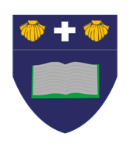
Westleigh Methodist Primary School
Weekly Newsletter: WC 14th April 2021
Welcome back to Westleigh!
We hope all of our families have had a fantastic Easter holiday! The children have spoken of fond memories with their families and have come back to school with smiles across their faces. We have seen wonderful learning behaviour in school this week and all children have been doing their best with all of their work. We are very impressed with the attitueds around school and the children look fantastic in their uniform setting an amazing example at all times.

Worship
Worship this week has been focussed on learning from our mistakes. The children discussed the mistakes that were made in the sinking of the titanic and how with small changes this could have possibly been averted. We also explained how easy it is to look back at a situation and explain what could have been different, however we are unable to change it now. What we can focus on instead is how we learn from our mistakes. We looked at the changes that have been made since the sinking of the Titanic to prevent this from happening again and looked at how we can bring this same thought process into our daily lives of learning from our mistakes and what we can do to try our best not to make the same mistake again.

Spring term recruitment
Over the spring term we were able to recruit some fantastic additions to the Westleigh family. You will have seen many of these staff members over the past few weeks around school, and we would like to formally congratulate them on their role in school and inform you as parents on our new staff members. We have appointed Mrs J McDowell as a teaching assistant in Year 2, Mrs S Pilkington as a teaching assistant in Year 4, Mrs C Whyte as a teaching assistant in Year 3 and also Mr A Brocken as a teaching assistant in Year 3. We are delighted to have these people join our team and they have all made a wonderful impression on the school and children, fitting in fantastically well. We know these additions to our family will significantly improve the education of your children throughout school!

Exciting news!
During worship this week Mrs Moragrega revealed some extremely exciting news to all of the children in school - she is expecting a baby! We as a staff, as I know all of you parents will be too, are delighted for Mrs Moragrega and that she is able to share this special news with the school community. We are on official countdown until September 2021 when Mrs Moragrega’s second daughter will be here to greet us. Congratulations!

School Holiday pattern 2020-21
School closes School opens
Autumn half-term: Weds 22nd Oct 2020 Mon 2nd Nov 2020
Christmas: Thurs 17th Dec 2020 Mon 4th Jan 2021
Spring half-term: Fri 12th Feb 2021 Mon 8th March 2021
Easter: Wed 31st Mar 2021 Wed 14th Apr 2021
Summer half-term: Fri 21st May 2021 Mon 7th June 2021
Summer: Fri 23rd July 2021
Year 3 swimming
From Monday 19th April, all of the Year 3 children will take part in swimming lessons as part of the national curriculum. It is expected for all children to take part in these lessons and it will give the children a positive life skill. They will have the opportunity to complete a swimming lesson every Monday for the remainder of the school year!

Star of the week:
Reception: Scarlett L
Year 1: Liam W
Year 2: Amy L
Year 3: Georgia U
Year 4: Ben R
Year 5: Archie S
Year 6: Charlie D

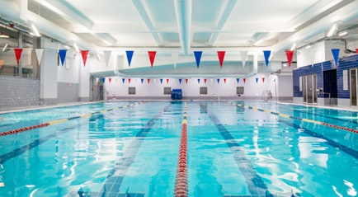

Visit our twitter pages
Please visit your child’s class twitter page to see all of the amazing work that is happening in every class. We are using twitter to really showcase the incredible curriculum opportunities that our children receive at Westleigh!
Year 1: @wlmyear1
Year 2: @wlmyear21
Year 3: @wlmyear3
Year 4: @wlmyear4
Year 5: @wlmyear5
Year 6: @wlmyear6

