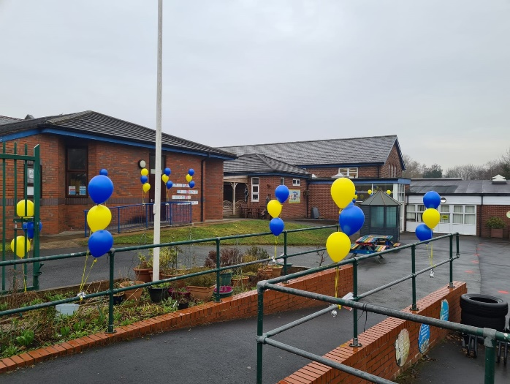
Westleigh Methodist Primary School
Weekly Newsletter: WC 8th March 2021

Welcome back!
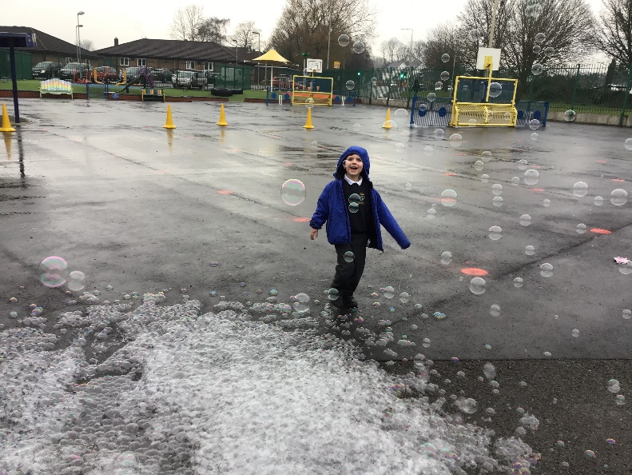
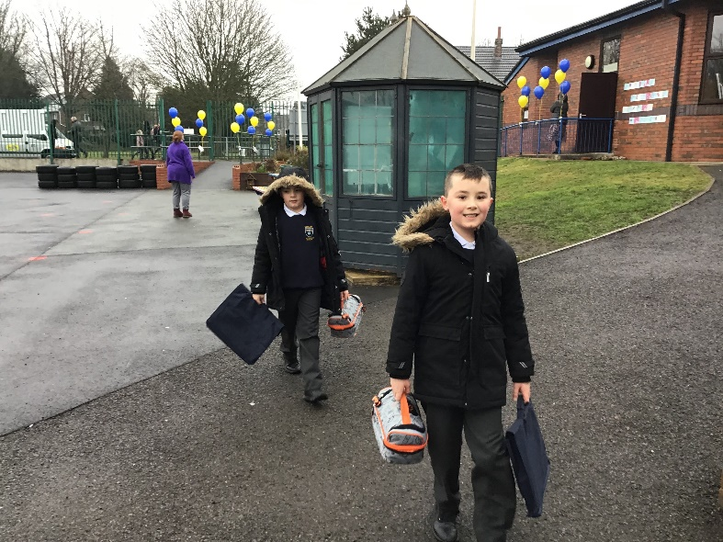
We have had the most magical week with all of the children back in school this week – it has been lovely having the Westleigh family back together!
On Monday it was lovely to see the smiles of the children as they came through the school gates, and there was also some understandable anxiety from some children who were then comforted and settled on entry as this was a big change in routine from the past eight weeks. However, once in school the children have been full of positivity, showing fantastic learning behaviour every single day. We are incredibly proud of how the children have transitioned back into the school routine and are matching our expectations at all times. We have also purchased extra fruit in school to ensure that every child in school has access to a healthy snack during break time.

Parents Evening
On Monday 22nd March 2021 we will be hosting our next Parent’s Evening. These consultations will be completed over the phone again with your child’s class teacher. Every parent will be able to book a 5 minute slot on the evening of Monday 22nd March between 3:30pm and 6pm. These consultations will focus on how your child has settled back into school since the return of all pupils and how the curriculum has been changed to support all of the children in school. There will be an opportunity to discuss your child’s next steps and any gaps that need addressing and there will be an time for you to ask any questions about your child and their education. To book a time for your child’s parent’s evening, please contact Mrs Clarke in our school office on: 01942 702967.
Thank you for your continued support in all that we do at Westleigh.

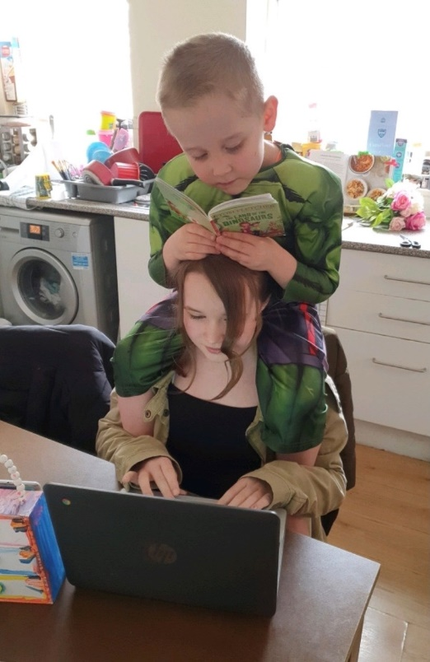
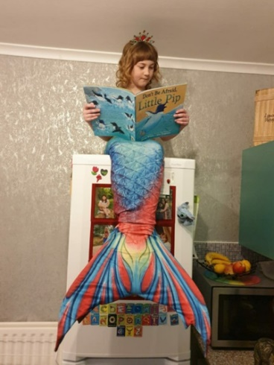
World Book Day
As a school, we made the decision to move our World Book Day event to this week so that we could celebrate as a whole school and we are so happy that we made this choice. It was wonderful seeing all of the children in their costumes and the wonderful activities that took place in every classroom over the day. We also enjoyed our first ‘read around’ where every single class was read to by all of the teachers from years 1-6. The teachers chose their favourite book and read this to each class in school on rotation. It was lovely speaking to the children later in the day and they were able to talk confidently about the different stories they had heard from the different teachers, it is so important to us that our children have a love of reading in and out of school. We also had our three different competitions running through school, the: book in a box, picture of reading in an unusual place and the best dressed. These were incredibly difficult competitions to judge, however the winners were chosen from each class and they all received a brand new story book to take home. In our eyes, all of the children are winners and they all received a book token that can be used to purchase their own book too. Please enjoy just some of the amazing photos of the children!
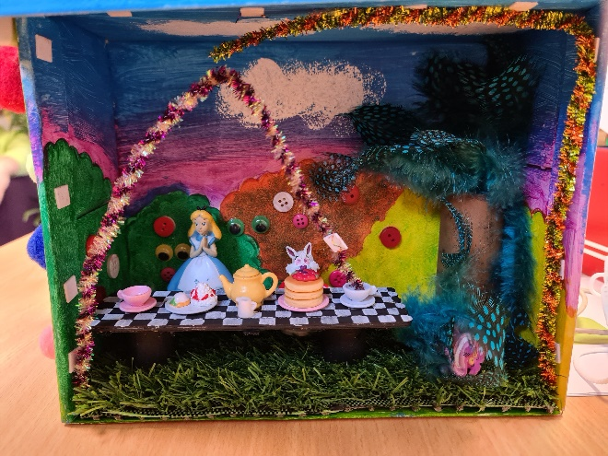

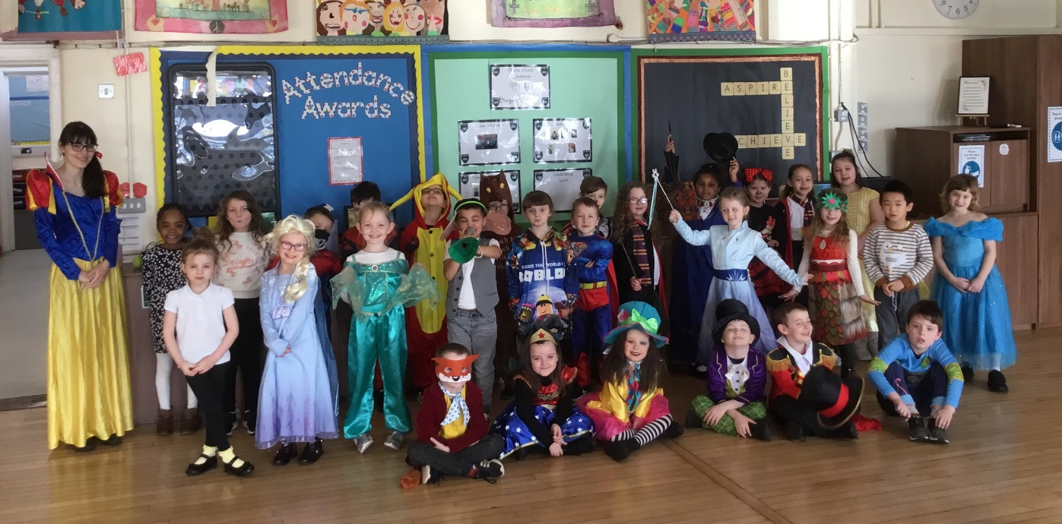
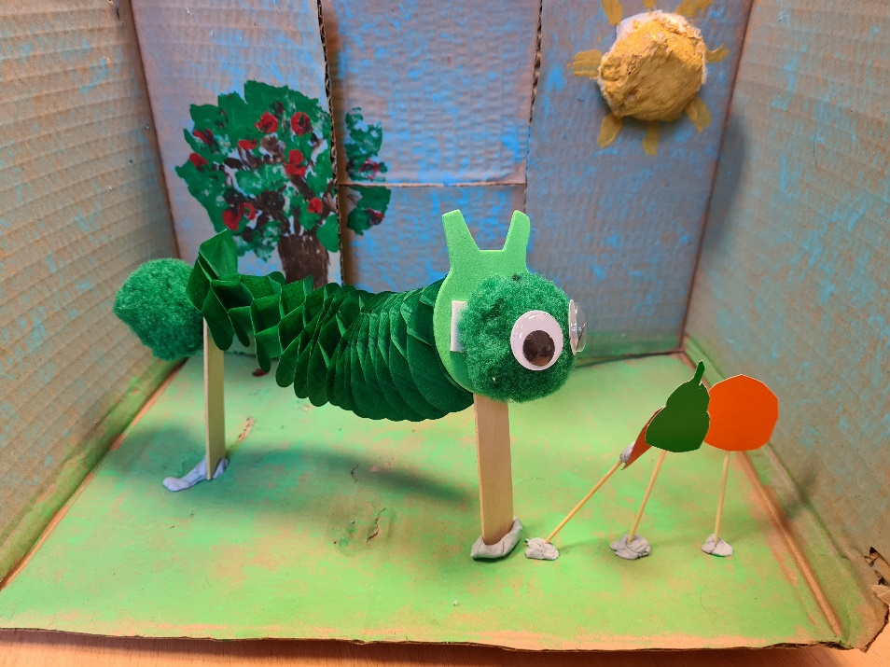
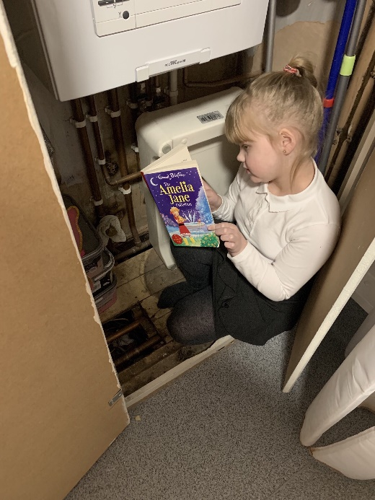
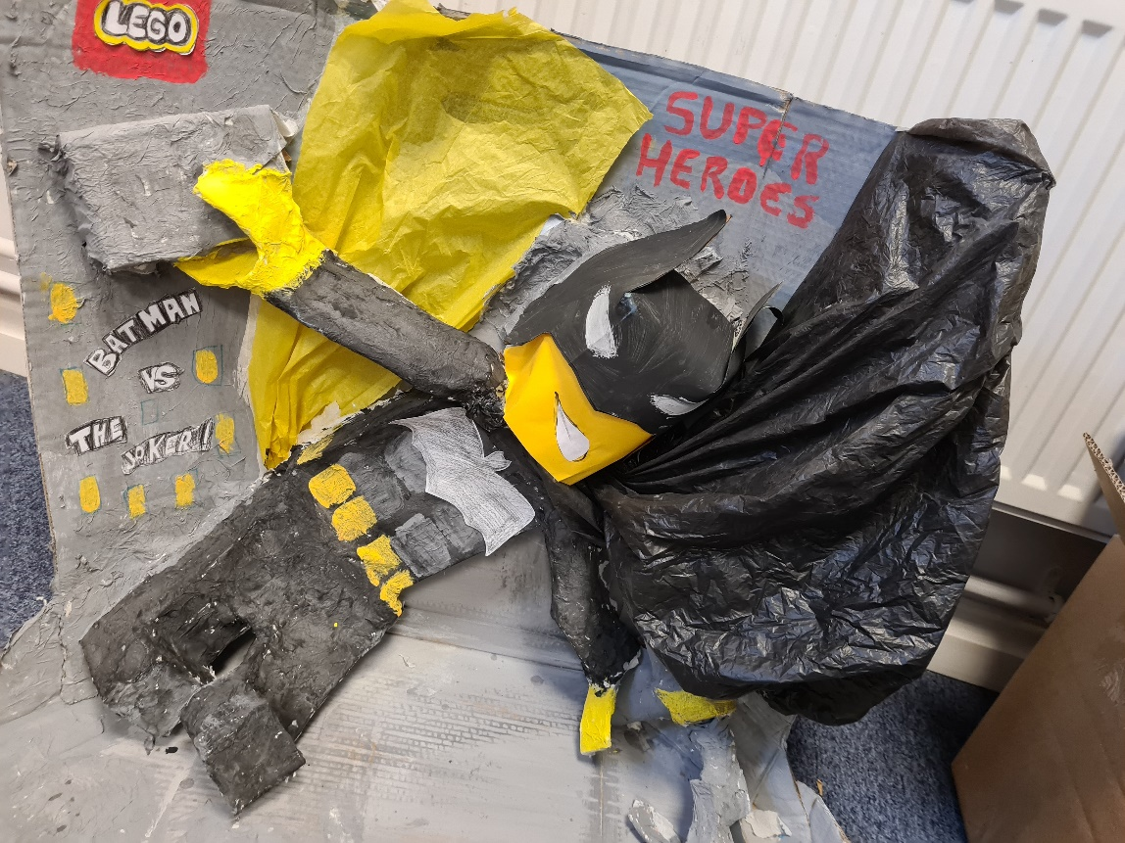
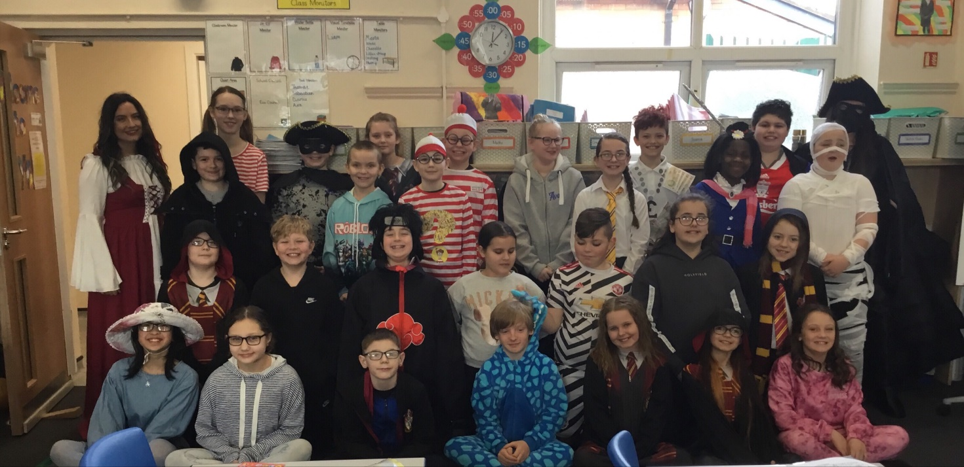

School Holiday pattern 2020-21
School closes School opens
Autumn half-term: Weds 22nd Oct 2020 Mon 2nd Nov 2020
Christmas: Thurs 17th Dec 2020 Mon 4th Jan 2021
Spring half-term: Fri 12th Feb 2021 Mon 8th March 2021
Easter: Wed 31st Mar 2021 Wed 14th Apr 2021
Summer half-term: Fri 21st May 2021 Mon 7th June 2021
Summer: Fri 23rd July 2021
Stars of remote learning
During our period of partial school closure, many of children continued their hard work through remote learning and each teacher awarded one children star of the week every week. Those children have now received their star badges!
Star of the week:
Reception: Jeffrey D
Year 1: Lainey-Mae K
Year 2: Julian K
Year 3: Aimee A
Year 4: Isabella M-F
Year 5: Jake L
Year 6: Taylor M
Resilience of the week
Reception:
Year 1: Lexi S
Year 2: Paisley S
Year 3: Olivia W
Year 4: Noah P
Year 5: Lacey C
Year 6: Amritdeep K

Social distancing on the playground
We would like to thank our parents and carers for supporting us in keeping school safe and social distancing on the playground. Please ensure you are on one red spot at the start and end of the day to ensure social distancing is happening on the playground. We also thank you for not loitering before and after school and leaving the premises as soon as your child(ren) have been dropped off or picked up. This is helping us keep school as safe as it possibly can be.
Thank you

Visit our twitter pages
Please visit your child’s class twitter page to see all of the amazing work that is happening in every class. We are using twitter to really showcase the incredible curriculum opportunities that our children receive at Westleigh!
Year 1: @wlmyear1
Year 2: @wlmyear21
Year 3: @wlmyear3
Year 4: @wlmyear4
Year 5: @wlmyear5
Year 6: @wlmyear6

